Issue 22: October 2022 Across the Midlands Region

Introduction
It is officially Autumn, which we can tell from the distinct change in weather. We know that the coming months will be difficult for many with the ongoing cost of living crisis; the ‘do I or don’t I’ question of putting the heating on or pulling on another jumper or blanket adds to the stress many of us already feel.
Please remember to speak to your line manager if you are struggling and remember there are many resources out there for NHS colleagues to look to for support and guidance, no matter how much or how little is required by you – here are just a few:

- https://www.england.nhs.uk/supporting-our-nhs-people/support-now/staff-mental-health-and-wellbeing-hubs/
- https://www.england.nhs.uk/supporting-our-nhs-people/how-to-guides/financial-wellbeing/financial-wellbeing-support/
- https://www.nhsemployers.org/publications/nhs-health-and-wellbeing-framework
- https://www.nhsemployers.org/articles/financial-wellbeing
- https://healthcareworkersfoundation.org/financial-support/
- https://www.nhshealthatwork.co.uk/

‘However difficult life may seem, there is always something you can do and succeed at’ Stephen Hawking

Each month we turn our awareness to many themes and this month there are many, including:
- Black History Month 2022 – see more from our Equality, Diversity and Inclusion lead further in this newsletter
- ADHD Awareness month: https://www.adhdawarenessmonth.org/
- Breast Cancer Awareness month: https://www.nationalbreastcancer.org/breast-cancer-awareness-month/
- Go Sober for October: https://www.gosober.org.uk/
- Stoptober: https://www.blf.org.uk/take-action/campaign-with-us/stoptober
- National Cholesterol Month 2022: https://www.heartuk.org.uk/news/latest/post/132-lets-talk-about-cholesterol
- Pituitary Awareness Month 2022: https://www.pituitary.org.uk/pituitary-awareness-month-living-well-2022/
- Lupus Awareness Month 2022: https://www.lupusuk.org.uk/raise-awareness/

We hope the October edition of our newsletter is of interest to you and your colleagues, if you have any colleagues that do not receive our newsletter please ask them to sign up through our website. If you have any suggestions of what could make our newsletter even better for you please contact us at midlands@leadershipacademy.nhs.uk.

GMTS update
September is always the most exciting and rewarding month in the Graduate Management Scheme as we welcome our new cohort to the Scheme and to the region. It was a pleasure to meet our new trainees in person at our regional welcome event held in Birmingham. The day was opened by our senior GMTS lead Gary Godden, followed by Dr Clare Price Dowd, Head of Leadership and Lifelong Learning in the Midlands who gave them a warm welcome to our region as well as giving our future leaders invaluable insight into the great achievements, and the current challenges, of healthcare in the Midlands.

Throughout the day we were delighted and extremely grateful to be joined an exciting array of speakers who took the time from their extremely busy schedules to join us as valued supporters and advocates of GMTS in the Midlands, sharing their own leadership journeys and their experiences of the Scheme and the NHS - in some cases both as former trainees and current managers of GMTS trainees.

We were also joined by some of our current trainees who shared their experience of the scheme, the exciting and crucial work they have been involved in on their placements and their knowledge of the geographical areas they serve, and who were most gracious in taking questions from, and connecting with, our new colleagues.

The day was brilliantly closed with inspirational words from the Right Honourable Paulette Hamilton MP for Birmingham Erdington who shared with us insights into her leadership journey, her experience as an NHS nurse, making a positive impact in your workplace and the importance of work-life balance.

We hope that our new trainees found the day welcoming, inspirational and energising as we did and valued the opportunity to connect with their peers, current and former trainees as well as the GMTS team in the Midlands as we look forward to supporting and working with them on their exciting, life-changing journey ahead.

Upcoming offers and programmes
Sustaining a Good Team Culture |  | Coaching for Improvement
This is an interactive, inclusive and practical learning burst style session to support line managers and team leads in creating, sustaining and in some cases resetting their team culture.  This is an opportunity for individuals to access practical, easy-to-apply methods and approaches which are designed to support their teams. Providing individuals with invaluable thinking time to consider their teams current culture baseline, and the strength of the team’s foundations combined with a focus on how to support teams to move forward.  Thursday 10 November 1:30 pm - 3:00 pm |  | This 3 day programme has been designed for colleagues working in roles and projects which involve Quality Improvement (QI), with a focus upon developing participants’ leadership effectiveness for QI through the application of a coaching approach.  What will be covered:  - The opportunity to work with colleagues from across organisations to share learning  - The opportunity to gain key skills around the application of coaching approaches to support staff engagement within change initiatives  - Increased awareness and understanding of the impact of group dynamics within change processes  - Increased understanding of the challenges within establishing and maintaining change  - Increased awareness of their personal response and impact (use of self as an agent of change)  Thursday 10 November 9:30 am - 4:30 pm
Mentoring CPD sessions |  | Coaching CPD sessions
Continued professional development for our trained mentors:  Strengths  Wednesday 19 October 9:30 am - 12:30 pm  Wellbeing  Wednesday 30 November 9:30 am - 12:30 pm  Behavioural Science  Wednesday 21 December 9:30 am - 12:30 pm  Motivation  Wednesday 25 January 9:30 am - 12:30 pm  Psychological Safety  Wednesday 22 February 9:30 am - 12:30 pm  Mentoring Tools  Wednesday 22 March 9:30 am - 12:30 pm |  | Continued professional development for our trained coaches:  Coming Back to Coaching  Cohort 1: Thursday 03 November 10:00 am – 11:00  Cohort 2: Wednesday 11 January 2:00 pm - 3:00 pm  Ethical Dilemmas  Cohort 1: Monday 07 November 9:00 am - 12:00 pm  Cohort 2: Wednesday 29 March 9:00 am - 12:00 pm  Express Coaching  Thursday 08 December 1:30 pm - 5:00 pm  Coaching Skills Lab  Thursday 05 January 10:00 am - 11:30 am  Coaching in a Hybrid Space  Monday 27 February 9:00 am - 12:00 pm

Primary Care
Impact of Long-Term Health Conditions

Designed to support Primary Care Networks (PCN’s) and other health and care professionals working in population health, participants will build their knowledge and skills within this area as well as:
- Develop skills in strategic planning for community based programmes for chronic long-term conditions and its implications on public health
- Inform health care workers, carers and family members who live or work with people with chronic condition in self-managements and self-care to bring about life-long change.
- To help people with long term chronic conditions regain their confidence, mobility, and return to exercise levels to improve and maintain their quality of life and functional independence
- To get guidance on how to re-navigate their way through the changes in the Health and Social Care system that have occurred post COVID

Monday 31st October: To Book
Monday 14th November: To Book
Monday 28th November: To Book
Monday 5th December: To Book

Equally Healthy
This masterclass is about leading with compassion to reduce health inequalities in your community. Designed and delivered to provide a practical approach to population health management, with a unique insight of behaviour science on leading and managing change to address inequalities.
The facilitators will be taking a different route into the perennial challenges of health inequalities and population health by exploring lived experiences from your population in advance of the session to reflect on the realities of ‘health inequalities’ in human terms and how you could usefully help, sharing thoughts with other participants.
They will explore how to have different conversations with your community, and how you might use psychology to influence a mindset shift around health inequalities.
Thursday 13 October 2:00 pm - 4:30 pm

Equality, Diversity and Inclusion

Proud to be part of the NHS... Celebrating diversity

During September this year, we were able to celebrate a number of events in the Midlands for Pride. Of which on the 24th and 25th saw Birmingham hold one of the largest, most successful Pride events ever. Around 300 NHS staff from the Midlands and 14 NHS Organisations provided two groups walking within the parade. As the parade is a march for equality and justice for all LGBT+ people, this is a great event and a clear way to show our support for our LGBT+ staff and patients.

As we move into October, this gives us the opportunity to celebrate Black History Month.
A chance to remember the achievements and contributions of black people not only in the UK but from around the world. A chance to celebrate and learn more and the Leadership Academy are pleased to offer a variety of events being held throughout the month. Starting from 3rd October information can be found here.

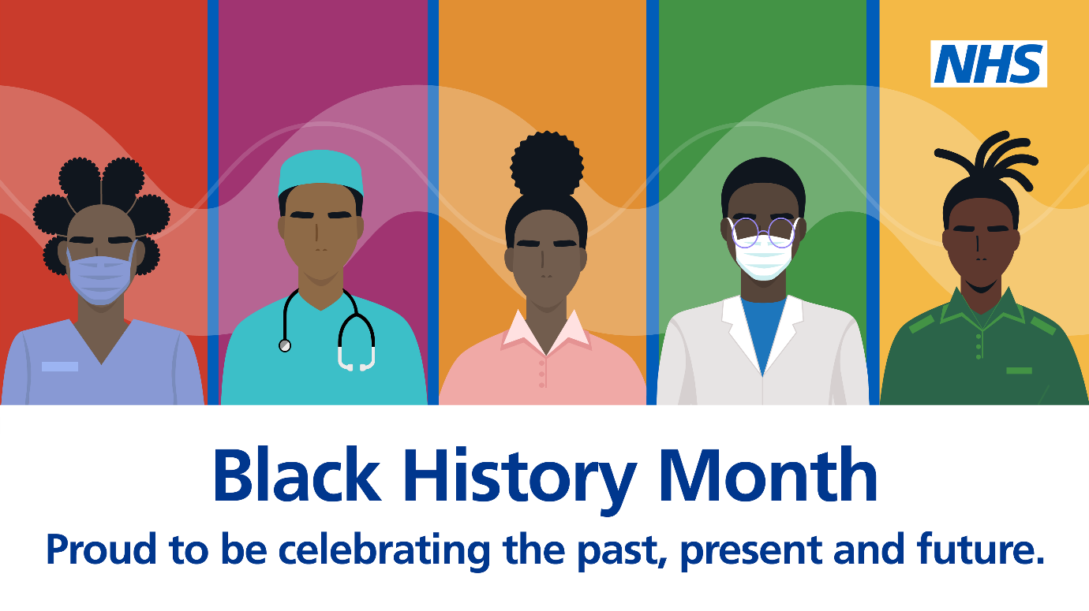

Further upcoming events are:-

5th October – Having Conversations around Mental Health in the Workplace. Presented by Amber Sorrell who gives help and advice on how to approach conversation around mental health in the workplace. Amber covers what mental health actually is, why it is important for businesses to consider and the difference between burn our and rust out. She advocates for a person centric approach and has a unique toolkit to aid these conversations. To register click here.

12th October – Creating Policy around menopause and what it can offer you – this event will focus on what a menopause policy should include and what this should offer you both as a manager and a member of staff. We will remind ourselves of the definition of menopause and its impact on the workforce and cover some myth-busting. We will explore what developments the Government is considering and why. To register click here.

13th October – EDI Celebration Masterclass Part 1. A programme of learning to celebrate what diversity can bring to the workplace, and the value a diverse workforce can bring. The focus is about how we inclusively lead our workforce by improving knowledge, understanding, and developing skills. To register click here.

3rd November – An Introductory Session on Neurodiversity by Jasmine Murphy – join Jasmine Murphy (Consultant in Dental Health and Public Health EDI Champion and NHSE) for an introductory session on neurodiversity. It is an important aspect of the EDI agenda for the NHS; not only ensuring that we are more inclusive about the needs of our neurodivergent colleagues but also that of the population that we serve in the work we do, particularly with our statutory mandate on reducing health inequalities. To register for this event here.

8th November – EDI Celebration Masterclass – Part 2 – a programme of learning in two parts, to support the celebration of what diversity and inclusion can bring to the workplace, and the value a diverse workforce can bring. This is available for all staff, especially those in any kind of leadership role. The focus is about how we inclusively lead our workforce by improving knowledge, understanding and developing skills. To register click here.

For all information and to register for the above events please look at our website here.

Below is a selection of key dates, awareness raising days and events, for the month of October, which reflect the diverse population of our staff.

2nd Feast of the Guardian Angels – Christian
5th Yom Kippur – Judaism, Dussehra – Dasara – Hindu
8th Mawlid al-Nabi – Islam
9th Birthday of Guru Ram Das – Sikh
10th Sukkot begins – Judaism,
17th Shemini Atzeret – Judaism
18th Feast of Saint Luke – Christian, Simchat Torah – Judaism,
18th World Menopause Day
24th Diwali – Deepavali – Hindu, Sikh, Jain, Bandi Chhor Divas – Sikh
28th Feast of Saints Simon and Jude – Christian
Other Exciting News!
New National Coaching and Mentoring Hub
Our new national NHS Leadership Academy Coaching and Mentoring Hub went live on the 6th September 2022.
There will be a number of benefits to the new hub: more user friendly, an increased number of coaches/mentors available, it will be a more inclusive open register, run more efficiently, with a wider reach for coaches nationally as part of the first phase with further improvements as we move forward.
The new site to register as a coach, coachee, mentor or mentee can be found here: Coaching and Mentoring Hub : NHS Leadership Academy
Congratulations to Gary and Yvonne

On 27th September, after 18 months of stretch and hard work, Yvonne and Gary [and Phillip Masuwa who recently moved to another role in the North East region] all successfully completed the Next generation SLT programme in NHS England.
This has been a development scheme for the exactly what it says, the Next Generation of Senior Leaders skilled and equipped to move up in their career.
Over the last 18 months they have completed three projects, one around risk, one diversity and inclusion and the final one around Patient and Carer Staff Stories. Since starting the programme, all three have gained promotions which is fantastic.
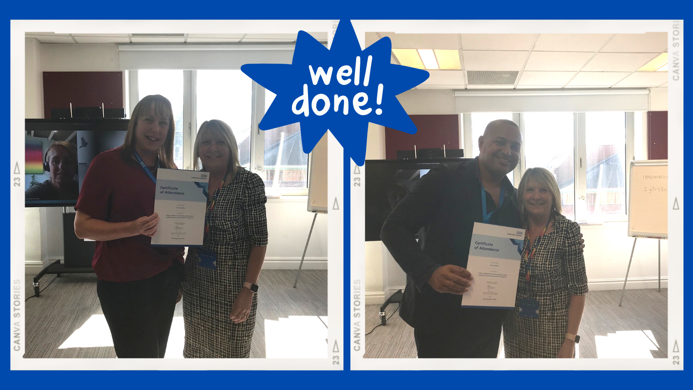
System Leadership Conference – Save the date!
On Wednesday 1st March 2023 we are going to be holding a Systems Leadership Conference which will include keynote speakers, workshops, action workshops, and an exhibition area and more! We still planning and so if you have any ideas, comments or thoughts please get in touch with us.

Contact us
We always welcome comment, news, information and feedback.

www.midlands.leadershipacademy.nhs.uk
@NHSMidsLLL
Email: Midlands@leadershipacademy.nhs.uk

Please subscribe to our newsletter by signing up here.
How we use your information
You can read how we use information in our Privacy Policy which has been updated in line with the General Data Protection Regulation ("GDPR"). Any information you have provided to the NHS Midlands Leadership Academy will only be used by us, our network of NHS Leadership Academies, your organisation and providers of services and will not be disclosed unless we are obliged to or permitted by law to do so. For member organisations we record attendance information and may share these details with your organisation for reporting purposes.
We only send emails about our latest offers and relevant information on key areas such as talent management, inclusion and system leadership to enable you to book on to further offers as well as be kept up to date. You can however Opt Out from email communications at any time by emailing us. We will then remove you from our mailing list.

