Issue 07: July 2021 Across the Midlands Region

Introduction
It has been 15 months since the Midlands Leadership Academy formed on 1st April 2020, following the joining of the East and West regions originally served by the East and West Midlands Leadership Academies. And, as with many other organisations, these 15 months have all been completed virtually with our team working from home. Our colleagues within the Midlands Leadership Academy span the country, not just from Midlands region but also from London, Stockport and Doncaster. We have seen colleagues come and go, huge recruitment drives have taken place, and we offered a full programmes of events for 2020/21 through from June 2020 to the end of March 2021 – all from our own home offices, arm chairs, the shade of the garden and with numerous visits on screen from partners, children and family pets.

From the MS Teams screen and Zoom meetings it is difficult to gauge what a colleague is really like; how tall are they? What size shoe are they? Indeed, what are they like from the waist that you can see from a laptop camera/webcam! On Monday 7th June 2021 our team finally got to meet in person and spend the day working together as a team (socially distanced of course). Here are the Midlands Leadership and Lifelong Team at our Nottingham office on the day:

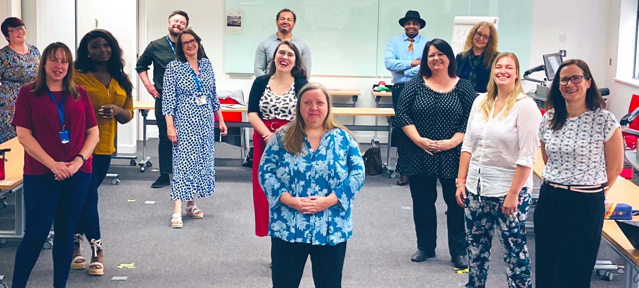

Whilst we welcome the flexibility that virtual working brings, we have missed the brainstorming on a flip chart, coloured sticky notes and marker pens. It gave the team a boost to meeting face to face and we look forward to meeting together in person more often, once the lockdown is fully lifted and as guidelines allow.

We hope you enjoy the July issue of our newsletter, if your colleagues are not yet receiving this please do ask them to sign up through our website.

Leadership Development
Healthcare Leadership Model – connecting with your leadership style.

If you are in a leadership role and have not already taken advantage of the free self-assessment tool, you can find it here. This tool is designed to help you to assess your leadership behaviours and more fully understand your leadership development.

We use the HLM to help leaders develop in a way that reflects the very best in care and compassion, alongside a focus on excellent in strategy, vision, direction and engagement. It describes what good leaders do, and it will help you develop as a leader by showing you how your leadership behaviours affect the culture and climate you, your colleagues and teams work in. Whether you work directly with patients and service users or not, you will realise what you do and how you behave will affect the experience of patients and service users of your organisation, the quality of care provided and the reputation of the organisation itself.

The dimensions of the model are:
- Inspiring shared purpose
- Leading with care
- Evaluating information
- Connecting our service
- Sharing the vision
- Engaging the team
- Holding to account
- Developing capability
- Influencing for results

To find out more, visit the HLM page on our website.

Living Well:

Emma Collier at Growth Pod shares her thoughts following the successful running of two Living Well workshops:

The pandemic has had a significant impact on the well-being of NHS colleagues. To help support people through this uncertain and complex time, we have been delivering training on understanding and managing individual and collective well-being.
Well-being is consciously understanding the natural highs and lows of life on our ability to be well and to be armed with the tools to navigate them positively.
Working with the scientific research of positive psychology we started with understanding the concept of well-being. We explored how it is made up of a number of building blocks before arming delegates with the tools to positively and pro-actively develop their own and others well-being.
We learnt how habits are created and looked at how to hack the science of habit development to create new and positive well-being habits that serve ourselves and others.
We finished our session with a calming guided neuro tapping mediation to promote the reduction of stress.
Many people left the session saying that they had become consciously aware of the need to develop self-care habits as we talked about not being able to pour from an empty cup.
Learning about how to use our strengths to boost well-being and performance was a big hit with many of the delegates. Most people were looking forward to mapping their strengths and intended on encouraging their colleagues to do the same now understanding how knowing their strengths can bring meaning to the work and create deeper and more meaningful relationships.
Every delegate said they would recommend the training to a colleague which is testament that well-being is such an important topic in these nebulous times.

Equality, diversity and inclusion
Pride month – June 2021

Pride Month occurs in June each year and commemorates the Stonewall riots, which were at the end of June 1969. As a result of this, many pride events are held during this month to recognize the impact LGBT+ people have had in the world. Although due to lockdown measures some events are unable to be held, we felt it was a good idea to use this opportunity to support our colleagues. You can do this in several ways, join the LGBT+ Network and/or become an ally to support all underrepresented groups, another way is to learn more about the LGBT+ community. Raising awareness and understanding is key.

To do this here are a couple of suggestions of what to watch
- Disclosure (Documentary on Netflix)
- It’s a sin (drama series on Prime/Netflix)
And, if you prefer reading, these may be of interest.
- Beyond the Gender Binary by ALOK
- Trans Like Me by CN Lester
- My Life As A Unicorn by Amrou Al-Kadhi
- Black and LGBTQ: Approaching Intersection Conversations by the Trevor Project

EDI Action Programmes in the Midlands
We would also like to take this opportunity to highlight some of the action programmes we are currently working on in the Midlands Leadership and Lifelong Learning team.

NHSE&I Peoples Voice Ambassadors
The Peoples Voice Ambassadors programme is a group of people who work with the joint purpose of building and supporting the NHS, from the perspective of the patient. Focussed within the Midlands, it enables individuals and patients who can share their lived experiences and to work collaboratively within the NHS to really make a positive difference in the services that the NHS provide.
Alex Evans, is one of our Peoples Voice Ambassadors and he is a Birmingham patient and NHS manager. To read more on his story on how he became involved in this work, please follow this link to our blog.

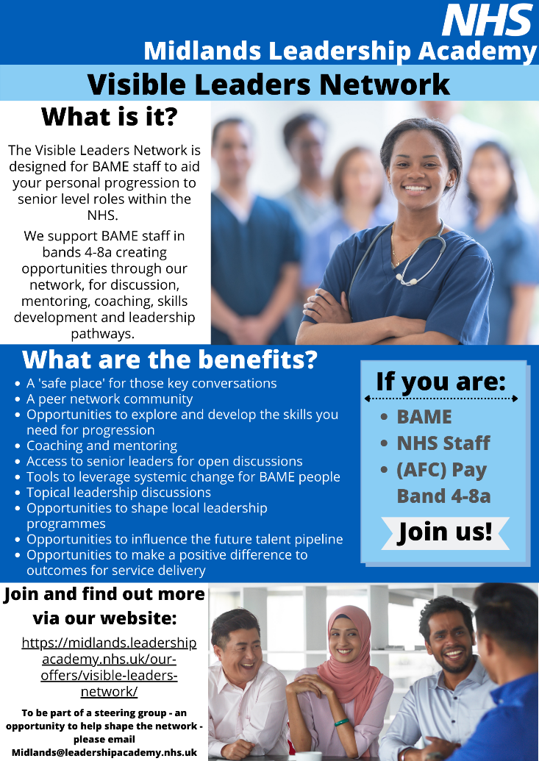
Visible Leaders Network

The Visible Leaders Network (VLN), is a network for Black, Asian and minority ethnic staff leaders and aspiring leaders and is designed to support your career progression to senior level roles within the NHS.
You can join the VLN if you are an NHS employee working in the Midlands at Bands 4 - 8a level.

Why the VLN?
In response to the Workforce Race Equality Standard (WRES), individuals and senior leads are looking for practical ways to develop and support aspiring Black, Asian and minority ethnic staff to achieve their full leadership potential.
To ensure we achieve this goal we are currently holding two listening events for VLN members to hear their views in what is required to provide the skills and tools needed for success both for the individual and for the NHS.

To find out more about the VLN or join see our website

Upcoming offers and programmes in June 2021
Midlands Talent Management Community of Practice |  | Gypsy, Roma and Travellers – Education and Awareness for reducing inequalities
Tuesday 13th July 2021 13:00-16:00  In this session, we will be building on existing relationships and forming new relationships to create a safe space for Talent specialists. As well as sharing and understanding your needs for talent management in your organisations and systems, we will be using appreciative enquiry to explore the current talent challenges we face and anticipated challenges post Covid. Alongside this, we will start to build a vision for Midlands Talent Management, helping you implement successful talent management approaches locally.  If you haven’t already, click here to book your place. If you would like to be added to the mailing list to receive updates and further information, please email us at aspire.togethermidlands@nhs.net |  | Tuesday 27 July 12:45 pm - 3:00 pm  In discussion with community, regional and national people, and Friends Families and Travellers FFT, a 2 hour virtual event has been organised to raise awareness of the issues and inequalities experienced by this community. This event follows on from the Launch event on 7th of April where FFT delivered an education and awareness event on the needs of Gypsy Roma Traveller communities.  This event is suitable for senior system leaders – Chairs, CEOs, ICS leads; Local Authority, Equalities Leads, Communications and Engagement Leads, statutory area across protected characteristics, charities; senior system leads with active involvement in equalities, Education, Police and Fire service  Click here to book your place
Equality, Diversity and inclusion in Primary Care |  |  | Coaching and Mentoring CPD’s
Thursday 8th July 13.00-15.00  Join this session to discuss the challenges of building effective EDI and staff networks within Primary Care and recommendations to overcome those barriers.  Click here to book your place  For any queries, please contact: ddlmc.gptf@nhs.net |  |  | Friday 16th July 10.00-11.00  Building belonging  Join to hear reflections on creating an inclusive culture through coaching and mentoring.  Click here to book your place

Celebration Of Leadership
Thursday 8th July 08:45 - 13:00

The event will provide an opportunity to attend a developmental workshop focussing on Signature Leadership, and the keynote speaker Caroline Elton will be sharing guidance on the importance of self-care in leadership.
There is also a fantastic range of optional workshops offered by organisations from across the region. These will be offered as Option A & Option B when booking to attend, please ensure that you choose one workshop from Option A and one workshop from Option B.

Click here to book your place

Systems
On 18th June 22 Nurses and Midwives along with their executive sponsors came together at the start of a new trailblazing programme specifically for aspiring nurse leaders from Black and Ethnic Minority backgrounds.

Our Midlands data shows very starkly that representation of non-white nurses in middle-level roles through to senior and very senior leadership positions is well below the levels of representation we need to achieve. This initiative has been a truly co-created partnership specifically to address this, drawing on the experiences of nurse leaders across the Midlands.
The programme was launched by our Midlands Regional Chief Nurse Siobhan Heathfield MBE, Jennifer Pearson the Regional Lead for Chief Nursing Officer’s Black & Minority Ethnic Strategic Advisory Group and Miriam Coffie the Midlands Head of Nursing Professional Standards. The participants received messages of congratulations from Jacqueline Dunkley-Bent, Chief Midwifery Officer NHS England, Angela Knight-Jackson, Head of Nursing development programmes, NHS England and Sue Tranker, Deputy CNO and soon to be first CNO for Wales.
Their call to action came from Professor Stacy Johnson MBE, from the University of Nottingham.

We will never achieve the change we need to see if we do not look to the medium-long term and start now but have specific development scheme - not just an isolated learning programme - which over the next 12 months will see 22 nurses and midwives, each with an executive sponsor, undertake leadership development, management and personal skills development, coaching, mentoring and deliver a system level stretch assignment that will deliver a change project.

The Midlands Leadership and Lifelong Learning team are proud to be supporting the programme and whilst it’s early days, if we need a different result and more representation in senior roles, we need a different approach to achieving that aim. This scheme has been designed to develop clinical professionals that will thrive when they take up senior roles.
We will be following their fortunes over the next three years and will give updates as our pioneering nurses progress.

Listening events:

In May 2021 the Midlands Leadership Academy held three listening events across the Midlands to understand the views of our stakeholders on leadership development, learning and talent management within the current operating environment and what the Leadership and Lifelong Learning team should focus on and prioritise in 2021/22. Over 40 stakeholders joined us at our listening events, which we ran by NHS Elect, and good conversations were held and noted which will inform our work in 2021/22 and planning going forward.

The aims of the listening events were to:
- Engage with Regional stakeholders to discuss and define the impact and implications of leadership during Covid-19​
- Realise how we can support each-other in the future for positive outcomes​
- Consider and discuss how we can support you in 2021/22​

If you were not able to attend one of the events and would like to give your feedback and suggestions to inform our work for 2021/22, please contact us through our inbox at midlands@leadershipacademy.nhs.uk

As we are now starting to procure and advertise our new offers for 2021/222, please do keep an eye on our website for the latest events on offer.

Talent management
Midlands and South West System Talent Management Co-Design Group
The Midlands and South West Talent Management teams hosted their first System Talent Management Co-Design Group in May.
The initial purpose of the group was to start to shape ideas on what good system talent management looks like with the view to designing a good practice blueprint focusing on the how. We also made a start in identifying areas where support is needed most as well as explored what we could co-produce together.
ICS’s will be expected to establish leadership structures and processes (including talent management and succession planning approaches) to drive the culture, behaviours and outcomes needed for people working in the system and the local population.
Furthermore, systems will be encouraged to plan to support the growth of the whole workforce for the future, including through collaborative recruitment and retention approaches, planning local educational capacity, and attracting local people into health and care employment and careers.
Against this backdrop, it’s never been more important for systems to collaborate on their people agendas and talent management is a key part of that.
For our second meeting, planned for the 15th July, we would like to extend invitations to senior system leads who have a responsibility for talent management to ensure all our systems are represented. In this session, we will explore our collective vision and formulate workstreams so we move from discussion to action.
If you are a senior system lead that have a responsibility for talent management and would like to join, please drop us a line at aspire.togethermidlands@nhs.net

Scope for Growth awareness sessions
The Midlands and South West regional talent teams will be hosting a series of one-hour informal awareness sessions sharing information on an exciting new career conversation tool – Scope for Growth. The sessions are aimed at HRDs, system and organisational talent management leads.

Scope for Growth is a new, inclusive, strength-based approach to person-centred career conversations. The framework supports organisations to structure career conversations around the priorities that matter to staff. It views everyone as talent and puts our NHS workforce at its centre so we can best understand our talent, their aspirations and help shape their career journey.

The framework covers 3 key areas:
- health and well-being, motivations, values, traits, behaviour and performance
- career history as a whole and levels of fulfilment
- current role and future career aspirations

These career conversations will underpin our work to embed Our Leadership Way, which aims to promote the right behaviours and empower our NHS people to live the People Promise through Our Head, Heart and Hands.

We are running 4 sessions to allow for colleagues to choose the most suitable date/time for them. All sessions will be the same in content, so if interested in coming along, please email us at aspire.togethermidlands@nhs.net with ONE date/time you wish to attend from the list below. We look forward to hearing from you.

- 27th July, 2-3pm
- 10th August, 2-3pm
- 24th August, 1-2pm
- 7th September, 2-3pm

Career pathways

As we start to introduce and describe the innovative Scope for Growth career conversation model with stakeholders, the team have been exploring career pathways.

Careers start with an understanding of what you want and need including:
- What’s important to you?
- What are your personal values?
- What kind of culture and/ or organisation would you like to work in?

It’s also asking the questions; do you want to:
- Deepen your understanding/ expertise?
- Broaden the range of experiences you have?
- Build on the complexity and responsibility that you have?

We’ve put together some super top tips on having an inclusive career conversation, common pitfalls and things that have helped to keep us in the NHS when we’ve have had itchy feet. To view the presentation, click here.

RTLB Board
In June, we were delighted to host the third Midlands Regional Talent and Leadership Board where we discussed current and future challenges and direction for Talent and Leadership strategy. We were especially pleased to welcome Jacqueline Davies, National Director of Leadership and Lifelong Learning to speak to us about her views on the strategic approach to preparing our services for the contemporary demands of tackling health inequalities in a world class NHS. The board were also briefed on the progress of the production of new Talent and Leadership models and frameworks which will be socialised further during June and July.

GMTS Update
Over the past few months, the GMTS team in the Midlands has received a great amount of high-quality bids to host trainees for our September intake, working with potential host organisations to quality assure placements that will give trainees fantastic experience and exposure to the NHS and prepare them for fulfilling and rewarding future careers and health and care as our future leaders. The team has also been liaising with candidates to allocate placements as well as preparing for the delivery of Programme and Placement Manager training sessions and our regional welcome event in July as we look forward to welcoming and supporting our new cohort in September, giving them a great introduction to our region and their start on the Scheme.

This month we also had Gary Godden begin in the role of GMTS Leadership Development Senior Manager. Gary is so enthusiastic and experienced that we can’t wait to see his impact on GMTS in the Midlands.

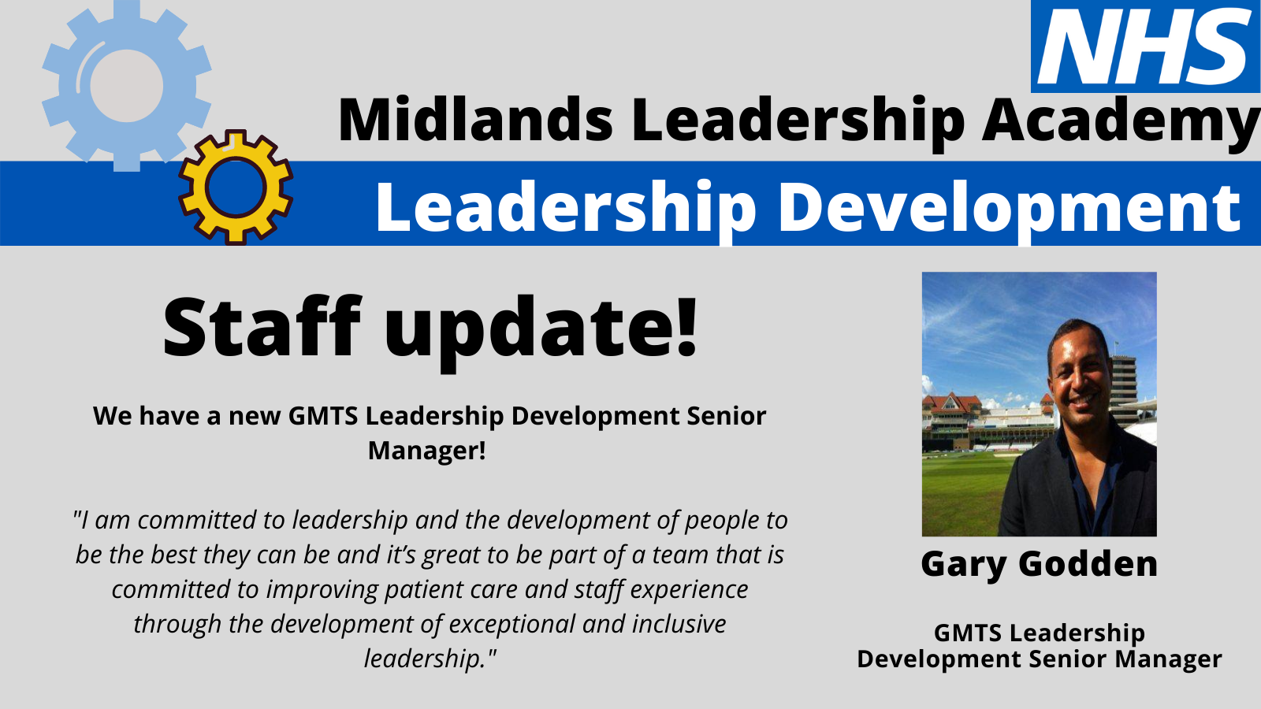

Health & Well-being
“In a growth mindset, challenges are exciting rather than threatening. So rather than thinking, oh, I’m going to reveal my weaknesses, you say, wow, here’s a chance to grow” - Carol Dweck, author and researcher, 2012.

From the moment we are born we experience change: we move schools, jobs, homes and see shifts in friendships and relationships and much more. Working for an organisation as large as the NHS, you will no doubt have been a part of, or at least witnessed, service transformation and change from regional to national level on a frequent basis. Change is inevitable. However, it can be difficult and if you’re struggling with personal or professional change and it’s impacting your health and well-being - we encourage you to reach out for support. A great personal resilience video can be found here: https://www.youtube.com/watch?v=1FDyiUEn8Vw

Support could also come in the form of a coach. In the Midlands region you can access, for free to NHS staff, our accredited list of coaches via CoachNet who can offer 1:1 coaching sessions. To understand more about what coaching is and how you might benefit watch our video. Or you can access health and wellbeing support information at: https://www.england.nhs.uk/supporting-our-nhs-people/wellbeing-support-options/support-offers/

Contact us
We always welcome comment, news, information and feedback.

www.midlands.leadershipacademy.nhs.uk
@NHSMidsLLL
Email: Midlands@leadershipacademy.nhs.uk

Please subscribe to our newsletter by signing up here.
How we use your information
You can read how we use information in our Privacy Policy which has been updated in line with the General Data Protection Regulation ("GDPR"). Any information you have provided to the NHS Midlands Leadership Academy will only be used by us, our network of NHS Leadership Academies, your organisation and providers of services and will not be disclosed unless we are obliged to or permitted by law to do so. For member organisations we record attendance information and may share these details with your organisation for reporting purposes.
We only send emails about our latest offers and relevant information on key areas such as talent management, inclusion and system leadership to enable you to book on to further offers as well as be kept up to date. You can however Opt Out from email communications at any time by emailing us. We will then remove you from our mailing list.

