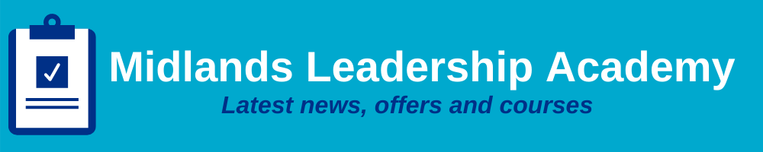
Issue 06: June 2021 Across the Midlands Region

Introduction
Many of us will now have felt the benefits of the third step of the roadmap out of lockdown as limits were eased and we were able to give our family and friends that long awaited hug, most businesses were able to open with Covid-secure guidance and large performances and sporting events were able to open their doors.

Nobody could have foreseen the tragedies that the pandemic has caused and we all look forward to step 4 of the roadmap coming from this month; the continuance of recovery and lives return to normal following the Covid-19 pandemic. Our thoughts go to all those that have lost and been affected by the pandemic, and to those countries that are still so affected.

We are working on our roadmap and our support of recovery and restoration for our NHS colleagues across the Midlands. More detail on what we are currently doing in the region is detailed throughout this month’s newsletter and as events are launched, they will be added to our website. For complete up to date information on all that is available throughout the year visit Midlands Leadership and Lifelong Learning Website.

Our Midlands Leadership and Lifelong Learning annual review for 2021/22 was launched on 7th May 2021 and a link to the document can be found here. Our team are especially proud of the work we have completed as a support to our NHS colleagues working through such a difficult year; and you will see that our delegate and provider feedback, along with our intervention numbers are a testament to the hard work and dedication of our leadership and lifelong learning team.

We hope you enjoy the June issue of our newsletter, if your colleagues are not yet receiving this please do ask them to sign up through our website.

Leadership Development
In Roman mythology, Janus was the god of beginnings and transitions and presided over passages, doors, gates and endings, as well as in transitional periods. He was usually depicted as having two faces looking at opposite ways, one towards the past and the other towards the future. This is what it feels like very much in our world of leadership development at the moment.

Looking forward we are planning for a time when we can blend learning online with some face-to-face interactions and start (cautiously) to meet up again as a team. We must not forget however, that this past year has been truly traumatic for so many.

We are right in the middle of our planning for leadership delivery for the rest of the year. Our listening events have led us to understand more about what you would like us to do. We have learnt what you have valued this year and also what you have missed - specific interventions that we did not deliver in the past year that will be part of our plans now. We have also heard that you want us to go back to some basics, think about new leaders, not just concentrating on the most senior, and working to ensure we have a pipeline of great talent for the future.

If you haven’t managed to get to one of our events, please email us your thoughts into our Midlands mailbox midlands@leadershipacademy.nhs.uk

17th to 24th May 2021 was ‘Learning at work week’. Whilst it is great to have this, every week should be an opportunity to learn at work and this is where we at the Midlands Leadership and Lifelong Learning team want to support leaders in the Midlands to be ‘lifelong learners’.

Michelangelo famously said ‘I’m still learning’ when he was 87, so what does it mean to be a lifelong Learner?

The key to this is curiosity and seeing every part of work as a vehicle for learning. What it is not, is going on a formal course every year for the whole of your career and then never putting that in to practice.

Lifelong learning can be formal, as part of a programme or a sequence of learning activity; it can be self-directed where there is control over pace and also subject and direction. Lifelong learning is often networked learning, through and with peers and friends - on the job, through hobbies etc. Some companies actively encourage this with periods of time in the workplace just to learn new things of interest.

The key to lifelong learning is to be open to opportunities. Here are a few ideas to get you started:
• Daily life - work, family, friends
• The colleagues around you - be curious - all the time
• Places where you are located, where you go - what can you learn about customer care from the places you visit for example
• Internet - the world of learning in your pocket
• Literature - books, journals
• Online - YouTube, Future Learn, Ted Talks etc
• Formal courses

The key is in being open to the possibilities around you, start small, learn one new thing that will help you do your job more effectively for example…. but keep going and look out for the new things from the team coming in June 2021.

Primary Care
Thank you for all that you and your teams have done, and are continuing to do, for your patients and communities over the last incredibly difficult year. As we embark on a new financial year we are looking towards our recovery and restoration continuing through the Covid-19 pandemic.

We will continue to offer our Primary Care colleagues’ different courses, programmes, action learning sets, coaching and peer support to help managers, individuals, leaders and PCNs grow their knowledge, skills, perspectives, confidence and resilience for better patient outcomes.

We recently finished our General Practice Working at Scale Programme which has helped to equip and enable Practice Managers and PCN managers to lead and manage change within their Practices and support the ongoing development of effective PCNs in the Midlands region.

Here are some of the responses from our Practice mangers:
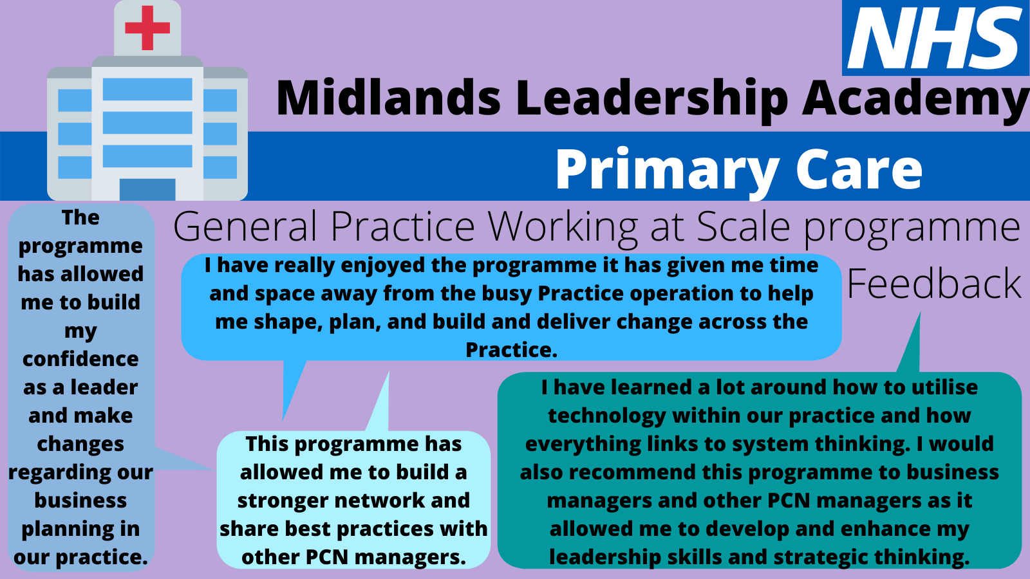

Upcoming offers and programmes in June 2021
Freedom to Speak Up Guardians – Lunch and Learn Session |  | Leadership & Change – Managing Change & Understanding Culture Workshop
A chance to meet our Freedom to Speak Up Guardians!  Come along and get to know who they are and what they do, with an opportunity to ask questions along the way about the valuable work they do for NHS staff across the region.  If you would like more information or an informal chat, please contact the Midlands Guardians at england.speakupmid@nhs.net (or directly Nick Hodgetts, Ruth Washbrook or Mary Idowu.)  Click here to book your place:  22nd June, 12:30-13:30 |  | This is a specialist 2-hour workshop that is aimed at any member of the multi-disciplinary team working in a Primary Care practice or PCN setting.  The workshop is a short session designed to support those in primary care to understand how to be more effective change agents, communicators and leaders. Evidence-based and well tested practical tools, techniques and resources will be shared to support day to day practice. Please click on the link for more information.  Leadership and Change workshop – Wednesday 2nd June
Living Well Workshop: Growing Collective Well-being |  |  |  | Midlands Talent Management Community of Practice
Well-being is consciously understanding the impact the natural highs and lows of life have on our ability to be well and to be armed with the skills to navigate them positively.  Click the below link to find out more and book your place:  Cohort 1: 14th June, 14:00-16:00  Cohort 2: 17th June, 17:00-19:00 |  |  |  | In our next Community of Practice session we will be building on existing relationships and forming new relationships to create a safe space for Talent specialists. As well as sharing and understanding your needs for talent management in your organisations and systems, we will be using appreciative enquiry to explore the current talent challenges we face and anticipated challenges post Covid. Alongside this, we will start to build a vision for Midlands Talent Management, helping you implement successful talent management approaches locally.  Open to all talent leads and practitioners in the Midlands!  Click here to book your place:  16th June 2021, 13:00-16:00  If you would like to be added to the mailing list to receive updates and further information, please email at aspire.togethermidlands@nhs.net

Lunch and Learn: Reducing inequalities amongst our staff- The WDES mirror
This powerful and interactive session is given by Stuart Moore, Senior Project Manager in the WDES Implementation Team, NHS England and NHS Improvement, who looks at the background of the Workforce Disability Equality Standard (WDES) and a summary of progress achieved since its introduction in 2019.
He also talks about how the WDES can be a powerful tool for building understanding about disabled staff working in the NHS and their career experiences, and how data can be used as an evidence base for developing and delivering actions that reduce inequalities.
Click the below link to find out more and book your place:
1st July 2021, 12:30 to 13:30

Equality, diversity and inclusion
Spreading the Learning – New Resources

We have updated our EDI Resources page on the website so do check this out.
The post event reports for the Inspiring Women in Leadership and Men as Allies, Making staff networks work for me, my team and my organisation and Religious Literacy, Chaplaincy, Culture: Elements of Multiplicity in the Workplace are accessible now. There is also some guidance and information for staff networks and resources provided by the Disability and Welling Network and Menopause Network following our lunch and learn sessions which you may find of interest.

Save the date!

Reducing inequalities amongst our staff - The WDES mirror - Lunch and Learn Session

1st July 2021
This powerful and interactive session given by Stuart Moore, Senior Project Manager in the WDES Implementation Team, NHS England and NHS Improvement, who looks at the background to the Workforce Disability Equality Standard (WDES) and a summary of progress achieved since its introduction in 2019.

He also talks about how the WDES can be powerful tool for building understanding about Disabled staff working in the NHS and their career experiences, and how data can be used as an evidence base for developing and delivering actions that reduce inequalities. Follow this link to book your place: Lunch and learn – 1st July.

Talent management
Recruiting and Promoting BAME Leaders Inclusively with Cultural Intelligence (CQ®) Masterclass with Jennifer Izekor

Last month, we were delighted to present our first Inclusive Talent Management Masterclass on "Recruiting and promoting BAME leaders Inclusively with Cultural Intelligence with the fabulous Jennifer Izekor, Founder and CEO of Above Difference. During this session, Jennifer outlined what ‘good’ looks like along with real examples and shared an overview of how the culture of an organisation impacts on the recruitment, retention and progression of BAME leaders and how enhanced CQ can help create a more inclusive and equitable workplace culture. We hope you found the session exciting, innovative and engaging and we look forward to welcoming you to future events as part of our Talent Management Inclusive Masterclass series. For those who attended, please don’t forget to fill out the evaluation form emailed to you. We will share the recording and presentation slides once we have received them. If you are interested in receiving a copy, please email us at aspire.togethermidlands@nhs.net.

Coming up in June…
June 2021 sees the launch of two programme to support the aspirations of the People Plan around developing a more inclusive and diverse pipeline.
- The first cohort of the Executive Director Pathway (EDP) will start next month. The EDP is an inclusive talent scheme which aims to support aspiring executive leaders to progress in their careers through a series of targeted development opportunities. It will take participants between 12–24 months to complete and provides a clear development journey towards senior executive leadership, combining best practice in both talent management and leadership development. We have nominated a strong cadre of eight participants from the South West onto the Executive Director Pathway scheme
- The Scope for Growth provides a strengths-based approach to career conversation that is inclusive and views everyone as talent. A joint discussion between the individual and their line manager will identify individual aspirations, where they want to move to and how they will do this to develop their career. A soft launch is planned through early adopters in late June 2021. The South West Talent team plans to do further engagement on the model when we have more clarity on how it will be rolled out.

Coaching and Mentoring
As we continue to grow and develop our workforce within the Midlands region, coaching and mentoring has been fundamental to our approach to organisational and individual successes within the NHS. We offer the service at no cost to the individual, and have the provision to enable the individual to receive both coaching and mentoring support, as well as the option to train in these skills and become one of our registered coaches or mentors within the Midlands NHS region.

Moving online has allowed this to become even more accessible as there are no travel requirements for sessions, and it has allowed for relationships to be created regardless of geographical distance, and we will continue to explore the possibility of face to face sessions when it is safe to do so.

We are in the early stages of our listening events to enquire and understand what support our workforce need from Midlands Coaching and Mentoring in 2021/22 and will be bringing out our training offers soon, in the meantime you can still register if you have previous experience and the relevant qualifications, as well as registering to receive coaching or mentoring at any time.

If you are new to coaching and mentoring and would like to learn more about it, we have a new video to explain the difference and the benefits of both. Click here to watch!

Health & Well-being
This month, we will see a focus on raising awareness of Men’s Mental Health (Awareness Week: 14th to 20th June 2021), a national concern that needs all our support. If you are a male struggling with your mental health or are concerned about a male in your life who is, please seek support https://www.menshealthforum.org.uk/mhw. Also, in the spotlight this month is Carers Week, an annual campaign to raise awareness of caring. The campaign will continue to highlight the challenges unpaid carers face and recognise the contribution they make to families and communities throughout the UK. If you are a carer, you can access help and support here: https://www.carersweek.org/

As a leader, do you role model your areas for development? More specifically, do you role model great health and well-being at work and at home? It has been said that: “Great leaders encourage leadership development by openly developing themselves” (Marshal Goldsmith). So often we can dismiss the importance of setting an example of good self-care. Consider putting some time aside to give focus to your own personal development plan in relation to good health and well-being and steps you can take for improvement. We have a wealth of information at our finger tips on our NHS England » Supporting our NHS people web page.

Contact us
We always welcome comment, news, information and feedback.

www.midlands.leadershipacademy.nhs.uk
@NHSMidsLLL
Email: Midlands@leadershipacademy.nhs.uk

Please subscribe to our newsletter by signing up here.
How we use your information
You can read how we use information in our Privacy Policy which has been updated in line with the General Data Protection Regulation ("GDPR"). Any information you have provided to the NHS Midlands Leadership Academy will only be used by us, our network of NHS Leadership Academies, your organisation and providers of services and will not be disclosed unless we are obliged to or permitted by law to do so. For member organisations we record attendance information and may share these details with your organisation for reporting purposes.
We only send emails about our latest offers and relevant information on key areas such as talent management, inclusion and system leadership to enable you to book on to further offers as well as be kept up to date. You can however Opt Out from email communications at any time by emailing us. We will then remove you from our mailing list.

